Dis-**Peru-Chavin-Jaguar with Crenelated crown, ca 250 BCE**

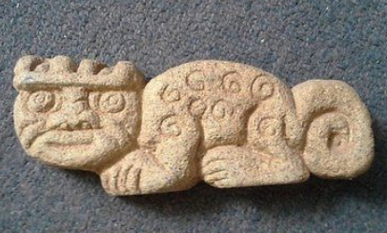

**Fig. 1. Chavin Jaguar Emblem with Crenelated Crown, ca 250 BCE**

**Formal Label: Peru-Chavin-Jaguar with Crenelated crown, ca 250 BCE**

**Accession Number:**

**LC Classification:** F3429.1.C48

**Date or Time Horizon:** ca 250 BCE

**Geographical Area**: Chavin de Huantar, 9° 35′ 34″ S, 77° 10′ 42″ W

**Map:** Chavin culture extent. Created by [en:User:Zenyu](https://en.wikipedia.org/wiki/User:Zenyu) and released to {{PD}} by Zenyu, source.

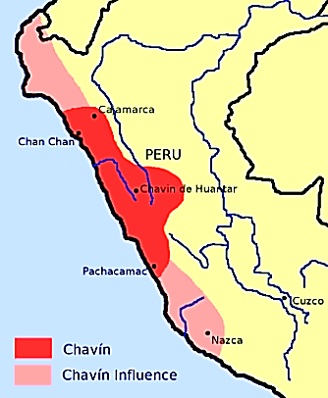

**Cultural Affiliation:** Chavin

**Medium:** White granite

**Dimensions: L 6 in**  
**Weight:**

**Provenance: Vemeros Guzman, Piscobamba NZ23 hote 8 urb. los Noranjor, los Olivos, Lima 39 Peru**

**Condition:** Museum quality

**Discussion:** The jaguar had a particular significance in many pre-Columbian cultures and most especially in the Chavin culture where its cult was known as that of El Lanzón, “the lance”.

Additional support was needed to claim this distinction, and the psychotropic cactus, *Echinopsis pachanoi* (syn. *Trichocereus pachanoi*), was increasingly used for this purpose. This cactus is native to the Andes Mountains at 2,000–3,000 m asl (6,600–9,800 ft asl) (Rätsch 2002: 15; Anderson 2001).

Cimora is a brew made from this cactus and is employed in a similar way to Ayahuasca. The ceremony was always held in the darkness of the subterranean chamber of the Chavin de Huantar temple before the central pillar (so-called “El Lanzón,” The Lance). This was needed because acolytes and practitioners had ingested cimora, which contains Mescalinethree thylamine compounds, Anhalonidine; Hordenine; and Tyramine. Today, in northern Peru, cimora is used by curanderos for divination, the diagnosis of disease, and to assume another's identity.

The post-contact name of this cactus, “San Pedro” (St. Peter) Cactus, refers to the abortive attempt of Catholic missionaries to suppress its use, because it was more successful as a psychotropic drug than the Eucharist and more effective as a medicine than European remedies. The people rejoindered to their suppressors in two ironical ways: “just as St Peter holds the keys to heaven, the effects of the cactus allow users ‘to reach heaven while still on earth’” (Anderson 2001: 45-49) and they also had called their elixir by a Catholic saint’s name so as to diffuse potential pharmacological inquiries into cimora by the dreaded Inquisition.

Cimora is made from fresh chopped cactus flesh that has been thoroughly dried in the sun (3 in thick and 10 in long for each dose). Then this is pulverized remembering that the finer the powder, the more effective the absorption of the mescaline. Then this powder is boiled for 5-7 hours with lime or lemon juice which assists in leeching the mescaline. Then the decoction is poured off and boiled again for 5-7 hours until only about half of the original volume remains.

In another unrelated way the botanical structure of the cactus proved important for the Chavín. The cactus has a columnar stalk, and whole stalks were held in a sacerdotal position by a leader of the jaguar cult as the a cimora ritual was performed. A bas-relief in the Chavin de Huantar temple provides a glimpse into how this ritual would have appeared.

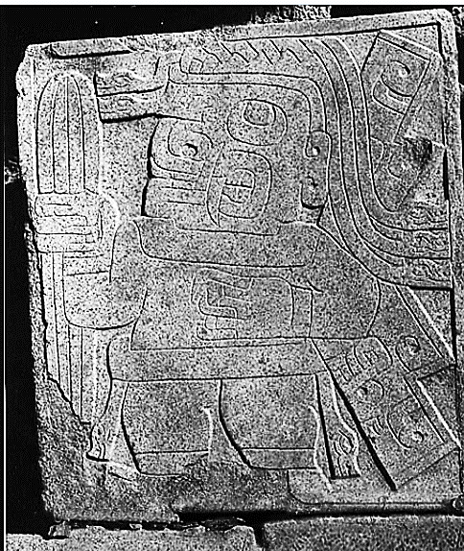

Fig. 6. A leader of the jaguar cult holding the sacred cactus in a bas-relief in the Chavin de Huantar temple. After <https://upload.wikimedia.org/wikipedia/commons/2/23/Chavin-cactus-stone.jpg>

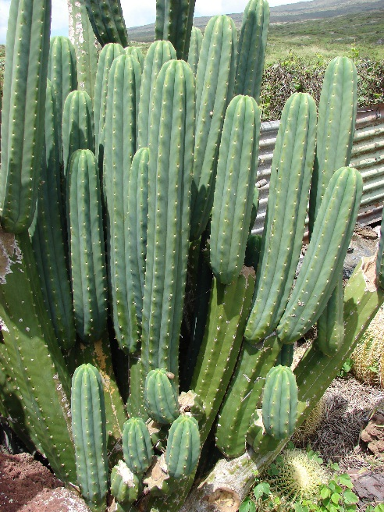

Fig. 7. *Echinopsis pachanoi* in Hawai’I, showing its columnar structure. After <https://upload.wikimedia.org/wikipedia/commons/6/62/Starr_070320-5799_Echinopsis_pachanoi.jpg>

Also, this sacred columnar structure of the cactus also offered architectural possibilities. *Echinopsis pachanoi* may have provided the inspiration for the columnar carved granite jaguar posts in the **Lanzón Gallery, located at the center of the Chavin de Huántar**.

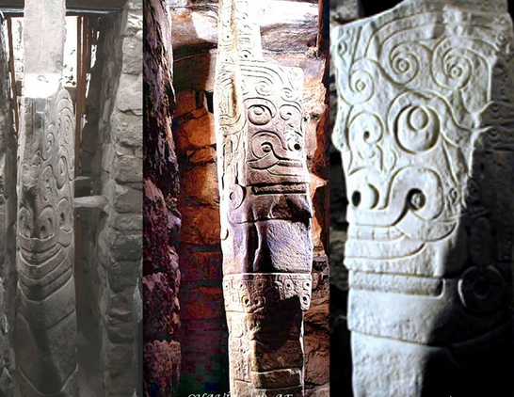

Fig. 5. **The Lanzón (subterranean) Gallery at the center of the Chavin de Huántar temple showing the jaguar motifs carved into the long, thin columns. After** <https://hiddenincatours.com/wp-content/uploads/2014/07/0-17Abril-Iconografias-Piedra-Lanz%C3%B3n-y-Obelisco-CHAV%C3%8DN-Galeria-01H-JPEG.jpg>

**This so-called El Lanzón Gallery, located at the center of the Chavin de Huántar temple, which contained columns with bas-reliefs of jaguar deity had as its focal point the central column which was suspended from the ceiling of this subterranean gallery:**

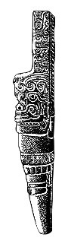 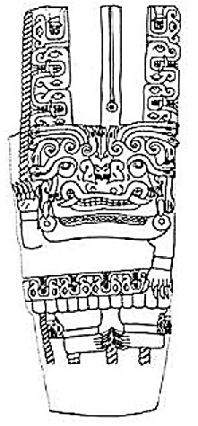 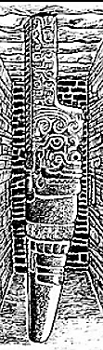

Fig. 5. **El Lanzón pillar at the center of the subterranean Chavín de Huántar temple chamber.** After Lizardo Travera, <http://3.bp.blogspot.com/-WU6Av9pv4j4/TdHd8id9D5I/AAAAAAAAAEc/PQt4S0Tecnk/s1600/chavin20.jpg>. and after http://1.bp.blogspot.com/_TIQdU8q_Tso/Sx_rR_M0x6I/AAAAAAAADfc/nTzzBqAz6uY/s320/Ubicaci%C3%B3n-Lanz%C3%B3n.gif.

Devotees would be led into the maze of pitch-black tunnels, eventually coming face to face with the sculpture's snarling mouth and upturned eyes. The worshipers' disorientation, in addition to the hallucinogenic effects of cimora they were given before entering, only heightened the visual and psychological impact of the sculpture. The central image of the Lanzon functions as an [axis mundi](https://en.wikipedia.org/wiki/Axis_mundi), a cosmological pivot linking the heavens, earth and underworld. Position within the temple also suggests centrality of image at the most sacred location

The Spanish conquistadores gave this the name of El Lanzón, “the lance” since they were all warriors, but its true name in the dialect of the Chavin is unknown. In any case the name would have reflected its being the central image of the jaguar cult. Notice that in the side view it is actually suspended from the ceiling of the subterranean temple where its profile suggests a Spanish lance.

Chavin de Huantar lies at an elevation of 3,150 m above sea level (hereinafter abbreviated asl) (10,330 ft asl). The temple buildings (Fig. 4) are located where the Rio Huachecsa flows into the Rio Mosna, a tributary of the Rio Maranon. This area encompasses three ecozones: the *quechua* (the montane valley), the *suni* (an area of scrubs and agriculture), and the *puna* (the mountaintop grasslands) (Burger 2008; Pulgar 1979). Chavín de Huantar was constructed in a sequence of perhaps fifteen phases and five stages. Beginning with high-volume structures containing gallery patios and elaborate galleries and ending with monumental low-volume structures containing standardized galleries: the trend suggests a shift from small internal patios based on discrete family units to large, decorated external spaces for communal gatherings. In the course of this progressive accommodation to an increasing population, the Lanzón monolith within the temple maintained its central importance (Kembel 2001).

In the initial Urabarriu period (900-500 BCE) the Chavin lived in dispersed settlements and depended on hunting and gathering as well as some primitive maize and potato agriculture. During this mostly egalitarian period a jaguar cult (called the Lanzón by Spanish conquistadores) developed that revered the powers of this feline mostly for hunting.

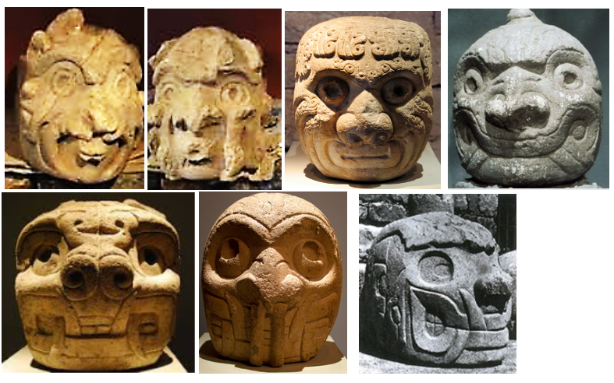

Fig. 4a-g. Representations of the jaguar from the Chavan de Huantar temple. The progression shown is from a transformational stage where the anthropomorph (the celebrant) is still observable as a human within a jaguar mask (Figs. 4a-c). Figs. 4d-f shows an anthropomorph with a jaguar mask and stylized fangs. Finally, Fig. 4g shows an anthropomorph face with a with a jaguar mask and highly stylized fangs and a stylized jaw. Note that in all stages of the progression the anthropomorph into a jaguar spirit the pupils are depicted as being dilated suggesting the subject has ingested hallucinatory drugs in a brew like that of the Cimora.

Precipitously, in one century (500-400 BCE), these dispersed settlements were abandoned and the people coalesced around the main ceremonial center Chavin de Huantar, which was situated between the Mosna and Huachecsa Rivers. Hunting gradually diminished as a sedentary lifestyle ensued with the domestication of llamas and the development of maize agriculture. Trade expanded with outlying settlements. The jaguar cult became less of an egalitarian lifestyle and more of a cult of élites.

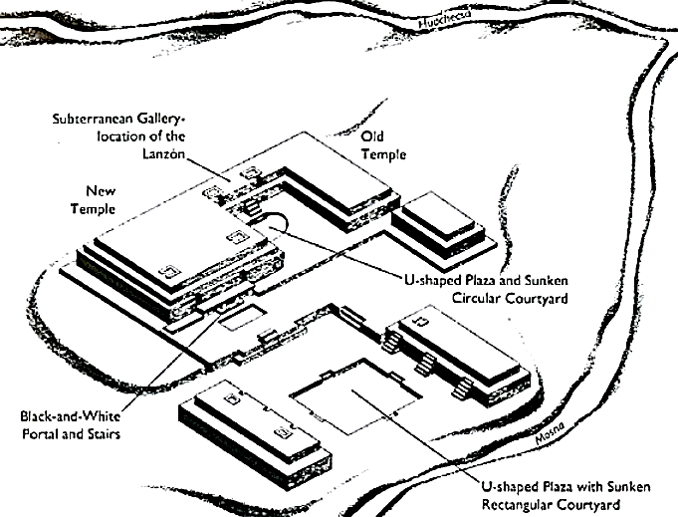

Fig. 5. Chavin de Huantar temple complex. Left, after <https://hiddenincatours.com/wp-content/uploads/2014/07/chavintemple.jpg>; right after <http://www.crystalinks.com/chavin_old%20temple.jpg>

The final stage of the Chavín culture, the Jarabarriu Period (400-250 BCE), also ensued precipitously. An ameliorated climate was accompanied by a dramatic increase in the production of crops and population. During this period the jaguar cult became solely a cult of élites based on the celebrated the qualities of the jaguar, which élites claimed to emulate (but probably no longer had to).

Thus, the cult of the jaguar had become a means of acquiring power. Now, those who were accepted into the cult, which had once required skill, strength, serenity and determination in performing the rites of defending Chavin territory, could do so without having to actually assimilate its quintessence. The cactus was their panacea.

This plaque of the jaguar reflects this last stage of the Chavin culture. During this period the quintessence of the jaguar cult had departed. The extensive remodeling of the Chavin de Huantar temple now became the new emblem of an artistic not a spiritual effort (Kembel and Rick 2005). The new temple was devoid of crenellations, but Jaguar emblems with crowning crenellations, such as on this plaque, became the symbols of an isolating culture. In reality, even the basic defensive architectural structures were missing. Perhaps, the symbol of the threat of retaliation against foes enclosed in a jaguar plaque was believed to be enough to quell anxieties. However, this trust of an élite cult did not reflect the political reality, for while warfare was not a significant factor in the last stage of Chavín culture, it was the instrument that hastened its end.

**References:**

Anderson, Edward F. 2001. The Cactus Family. Pentland, Oregon: Timber Press.

Burger, Richard L. 2008. "Chavin de Huantar and its Sphere of Influence", In *Handbook of South American Archeology*, edited by H. Silverman and W. Isbell. New York: Springer, pp. 681–706.

Burger, Richard L., and Nikolaas J. Van Der Merwe (1990). "Maize and the Origin of Highland Chavín Civilization: An Isotopic Perspective," *American Anthropologist* 92(1):85–95.

Bussman, Rainer W.  and Douglas Sharon. 2006. “Traditional medicinal plant use in Northern Peru: tracking two thousand years of healing culture,” *Journal of Ethnobiology and Ethnomedicine*, **2**:47.

Cruz Sánchez G. 1948. “Informe sobre las aplicaciones populares de la cimora en el norte del Perú,” *Revista de Farmacologia y Medicina Experimental Lim*a, 1: 253-258.

Dobkin de Rios M. 1969. “Folk curing with a psychedelic cactus in North Coast Peru,” *International Journal of Social Psychiatry*, 15: 23-32.

Kembel, Silvia Rodriquez. 2001. “Architectural sequence and chronology of Huantar de Chavín, Peru.” Ph.D. diss. Stanford University.

Kembel, Silvia Rodriquez and John W. Rick. 2005. "Building Authority at Chavin de Huantar: Models of Social Organization and Development in the Initial Period and Early Horizon", in Helaine Silverman(ed.), *Andean Archaeology*, Malden, Massachusetts: Blackwell Publishers.

Pulgar Vidal, Javier. 1979. *Geografía del Perú; Las Ocho Regiones Naturales del Perú.* Edit. Universo S.A., Lima 1979.

Rätsch, Christian. 2002. Enzyklopädie der psychoaktiven Pflanzen. Botanik, Ethnopharmakologie und Anwendungen. Aarau: AT-Verlag. p. 15.